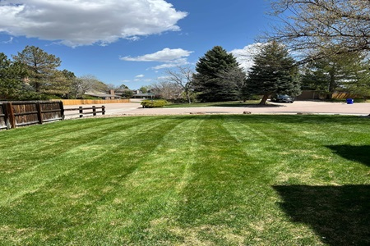  YSL lawn care  11/08/2024 | wireframe  The YSL Lawn Care website proposal outlines a responsive, visually appealing platform tailored to residential and commercial clients. Featuring a nature-inspired design, clear service sections, and interactive elements, the site offers a user-friendly experience across all devices.  DonnieRanjel  Intro to Web Authoring

Table of Contents
Client Overview 2
Design & Implementation 2
Template 2
Home Page 3
About Us 4
Gallery 4
Services 5
Contact Us 5
Conclusion 6
Wireframes 7
Mobile Viewport 7
Tablet Viewport 8
Desktop Viewport 9

Donnie Ranjel
Instructor Heidi Boucher
CWB1010X00 Intro to Web Authoring
11/08/2024
YSL Lawn Care:
Proposal & Wireframe

Client Overview
YSL Lawn Care offers a range of services tailored for both residential and commercial property owners, and we are committed to meeting the diverse landscaping needs of all clients. Our website is designed with multiple key goals in mind. Primarily, it aims to showcase the quality of our work and the array of services we provide. Additionally, we offer free tips and resources, empowering users to effectively plan and maintain their lawn care.
The main objective of our site is to remove barriers among residential and small commercial property owners who are seeking professional landscaping solutions. To create a warm, natural aesthetic, we’ve chosen a color palette inspired by nature, incorporating soothing shades of green, white, and brown. For typography, Bona Nova SC is used in titles and headers to create an elegant, timeless feel, while Lora is used for body text, ensuring readability and a polished look.
Visual content will play a key role in connecting visitors to our services. A collection of high-quality images and an engaging video will allow potential clients to see how our services can meet their landscaping needs. We aim to complete and launch this website by November 25, 2024, ready to serve as a helpful, visually appealing resource for all who visit.

Design & Implementation

Template
The website template will feature consistent content across all pages tailored for each viewport. Three images will be generated: a favicon, a logo for mobile devices, and a logo for tablet and desktop platforms.
The mobile viewport, Figure 1, will include a compact, sticky logo that remains fixed at the top of the page while scrolling. The top and bottom portion of the page for the header and footer will be green. The navigation will utilize a hamburger menu, positioned at the top. The main area will have a white background for improved readability and reduced data usage.
The tablet viewport, Figure 2, a larger alternate logo featuring the company name will be positioned relatively at the top. The navigation menu will appear below the logo, with vertical lines separating each menu item. The site’s background will have a green and white radial gradient for a more dynamic appearance.
The desktop viewport, Figure 3, the logo will be positioned in the top left corner, with the navigation menu styled similarly to the tablet view, also located in the top left. The background will continue the radial gradient theme. The footer will remain consistent across all viewport sizes, displaying the company’s email, phone number in the center and social media icons on the right to link to social pages, except for the site map at bottom left will only be on tablets and desktops. On hover, the text color for these items will change on the desktop view. In the mobile view, the phone number will be clickable to initiate a call.

Home Page
YSL Lawn Care's home page has wireframes below this document. The mobile viewport webpage, Figure 1, will exhibit simplicity ensuring that the core objectives of the website are effectively communicated. The main area of the home page will feature the company's name prominently, followed by a promotional offer to include a free maintenance checklist with services. After will be an emphasis to a button to call company’s phone number. Under is the hours of operations. Under that are sources to links for educational resources for lawn care and the links are in a multiple-column of two.
The tablet viewport, Figure 2, the layout will take on a more structured format, optimizing content presentation while enhancing user convenience. The hero image will be prominently placed below the navigation menu, stretching across the screen to maximize visual impact. The company’s name will display large and follow a sales pitch. This will have animation that will change text size and color. Below the pitch, are image-based links that appear in a three-column layout. On top of those links are text to describe the link. Below that is the resource area that is one the mobile viewport except the font color and size was changed.
The desktop viewport, Figure 3, will showcase a more sophisticated and content-rich layout, designed to a wider viewport. The main area will begin with the same hero image from the tablet version, maintaining visual consistency. Following the hero image, a more detailed and polished text block will provide an in-depth overview of the website's purpose and features. Beneath this, are complex images with the text. These image blocks will feature subtle box shadows that appear when hovered over, enhancing interactivity and creating a dynamic browsing experience. The middle image will transition to a after photo when hovering. Below that is the resource are in the tablet viewport except with a three-column layout. This refined design will ensure that the desktop version of the site conveys both professionalism and ease of navigation, tailored for users who seek a more engaging and immersive experience.

About Us
The Safety Board will be a central hub for users to access the most up-to-date and relevant safety information, organized into sections covering trending safety topics and accompanied by three core links designed to provide in-depth resources. The first link will direct users to the newsletter, The articles will be written in an engaging, informative style, covering both the latest news and emerging trends in workplace safety. Readers will gain insight into new technologies, regulatory changes, and preventative strategies that can help improve safety standards in their respective fields. With a focus on continuous learning, the newsletter will be regularly updated to keep users well-informed about the evolving safety landscape.
The second link will lead to users to an interactive and engaging learning page. This page will serve as an educational tool, designed to bring safety concepts to life through real-world examples. It will focus on common workplace scenarios, shedding light on everyday situations where safety risks may go unnoticed. By highlighting these often-overlooked hazards, the page will raise awareness and provide practical solutions to minimize risks. The learning experience will be enriched with visually appealing data charts that present safety statistics and trends in a clear, digestible format. In addition, users will find a section dedicated to monthly hazmat substance definitions, offering key facts and safety precautions associated with various hazardous materials. To further enhance understanding, the page will feature interactive content, such as multiple-choice quizzes and scenario-based exercises, allowing users to test their knowledge and apply what they’ve learned in a fun and engaging way. This page will also feature data charts, monthly hazmat substance definitions, and interactive content such as multiple-choice quizzes to enhance understanding.
The third link will provide access to a collaborative learning page, showcasing tables with the top monthly safety mitigations, encouraging users to engage in discussions and shared learning.

Gallery
The Gallery page will be designed with three distinct sections, each allowing visitors to explore and enlarge images to get a closer look at YSL Lawn Care’s work. Organized into categories that mirror the order of services on the Services page—Mowing, Yard Clean-Up, and Snow Removal—this layout will provide a seamless and cohesive browsing experience.
Each section will contain a curated set of high-quality images showcasing YSL Lawn Care’s expertise in that specific service area. Users can easily switch between categories, and each selected image will expand to a larger view above, offering a detailed look at the craftsmanship and results YSL Lawn Care consistently delivers. This intuitive, visually rich layout will allow potential customers to appreciate the company's high standards and attention to detail across different types of lawn care services.

Services
The Services page for YSL Lawn Care will feature a comprehensive overview of the primary services offered, presented in an organized and visually appealing layout. At the top of the page, an eye-catching hero image will capture visitors' attention, setting a professional tone and reflecting the high quality of YSL Lawn Care’s work.
Each service section will be thoughtfully organized to provide users with clear, accessible information. The first section, titled "Mowing," will include a concise description of mowing services, outlining key benefits and features. Directly beneath this, a large, engaging hero image will showcase a beautifully maintained lawn, creating a vivid impression of the results YSL Lawn Care delivers.
Following the Mowing section, the page will continue with additional services, including "Yard Clean-Up" and "Snow Removal." Each of these sections will include a brief overview and a dedicated hero image, allowing visitors to quickly understand the range of services provided. This format will ensure that all service details are easily accessible and visually appealing, enhancing the overall user experience.

Contact Us
The contact page will have centered elements containing welcoming text, styled to be inviting. Phone number will be below with a button link on phone to directly call, and text for tablet and desktop displays. The email link will works regardless of platform, however, the interaction will differ. The email text link will be blue for traditional appearance and will change colors when hovering and visited on desktop. The address of the training facility will be below and have styled text. Complementing the address will be a responsive, interactive map, providing users with an intuitive visual reference. At the bottom of the page, a comprehensive form will be included to gather essential information. This form will allow users to submit their contact details for various purposes, such as receiving notifications, subscribing to newsletters, or submitting inquiries. The form will be thoughtfully designed to collect the necessary data in a streamlined manner, ensuring efficient communication and fostering a responsive connection with users. Every element of the page will be crafted to facilitate seamless interaction, providing users with an intuitive and engaging experience.

Conclusion
In summary, the YSL Lawn Care website proposal and wireframe establish a clear vision for a user-friendly, visually compelling, and informative platform. Each aspect of the design—whether it’s the structured template, cohesive color scheme, or thoughtfully chosen typography—works to enhance the overall user experience and reinforce YSL Lawn Care's commitment to quality service. The responsive design ensures that the site will be equally effective and attractive across all devices, from mobile phones to desktops, accommodating users with varying browsing preferences and needs.
The website’s layout and content are carefully designed to meet both the functional and aesthetic needs of the target audience, including residential and small commercial property owners. With interactive features, high-quality visuals, and informative resources, potential clients will find ample opportunities to explore and connect with YSL Lawn Care’s services. The planned launch by November 25, 2024, marks a pivotal step for the company, positioning YSL Lawn Care as an accessible, trustworthy, and resource-rich solution for landscaping needs in the community.

Wireframes

Mobile Viewport

Figure 1
(720) 808 - 4164
Item 1
Item 3
Item 5

Item 2
Item 4
Item 6

Text for site resource offerings in multi column

YSL Lawn Care

YSL Lawn Care promotional deal
Text to call phone.

Business Hours
Line 1
Line 2
Line 3
Line 4
720-808-4164
ysllawncare@gmail.com

Tablet Viewport

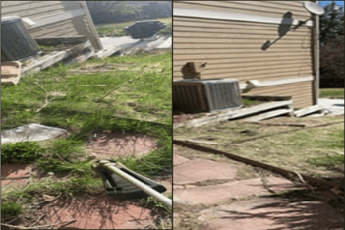


Figure 2
Item 2
Item 4
Item 6
Item 1
Item 3
Item 5
Text for site resource offerings in multi column
Have Questions?

What We Do

Landscape Technicians

Services
Contact Us

Home
About Us
Gallery

720-808-4164
ysllawncare@gmail.com
Home | About Us | Gallery | Services | Contact Us

Hero Image
YSL Lawn Care
Additional sales pitch text.

Desktop Viewport
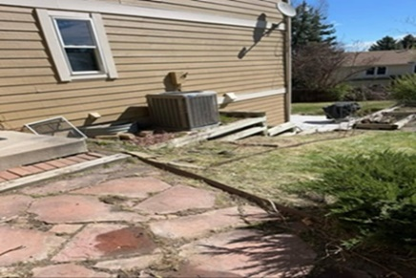


Figure 3
Services
Contact Us
Home
About Us
Gallery
Home | About Us | Gallery | Services | Contact Us

Have Questions?
What We Do
Landscape Technicians
Item 3
Item 6
Item 2
Item 5
Item 1
Item 4
Text for site resource offerings in multi column
720-808-4164
ysllawncare@gmail.com
YSL Lawn Care
Additional sales pitch text.
Hero Image
(I need this image.)

